## **Project “Heritage of Kings” 1.5-Page GDD**

*Aralon meets Medieval Total War 2*

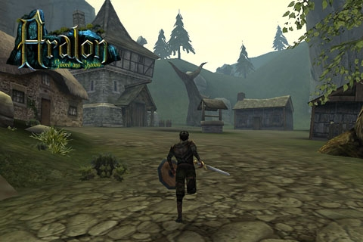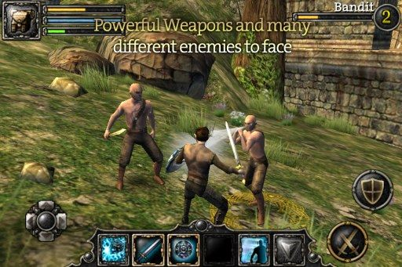

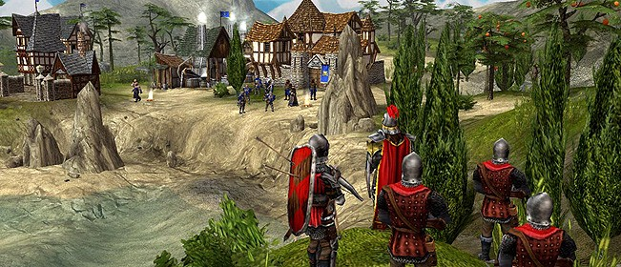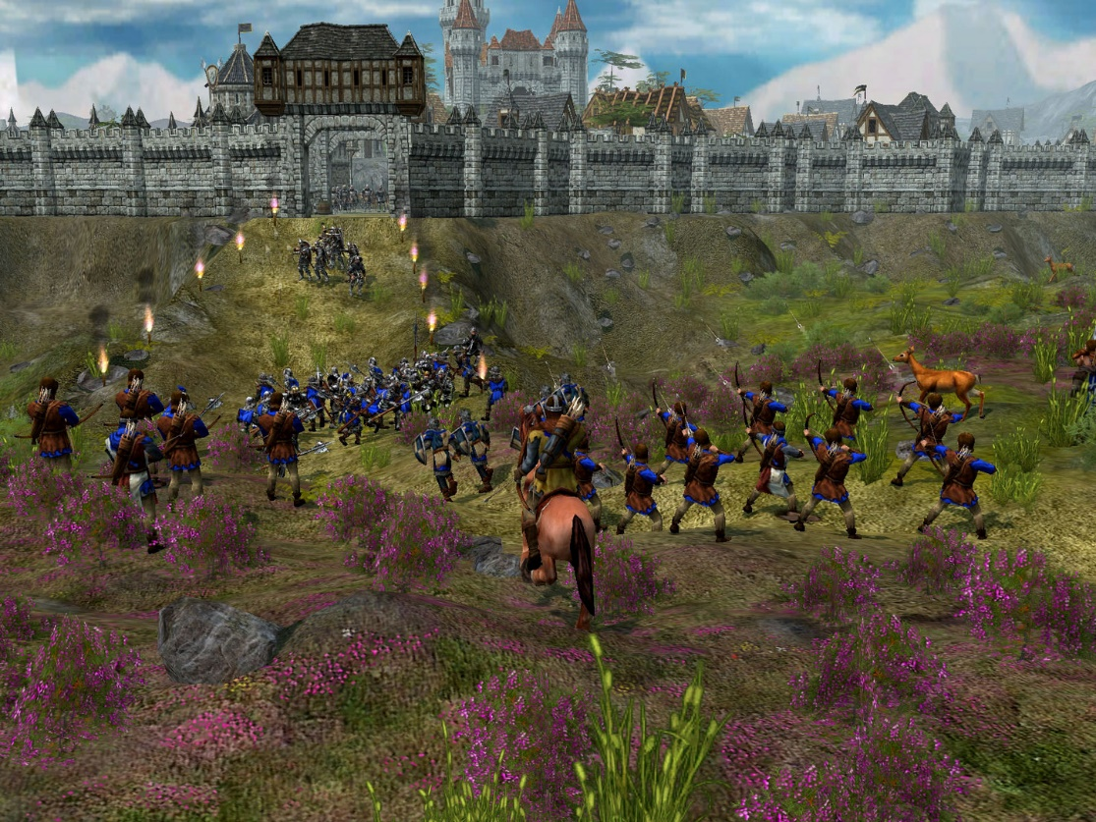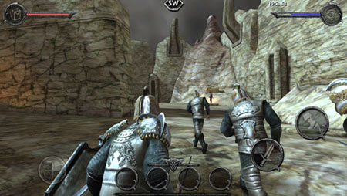

**Genre:** 3rd Person action RPG, Singeplayer  
**Target Audience:** Ages 13+ (Teens & Adults)

**Controls:** Mouse and Keyboard

**Thematic Setting:** Medieval Europe with Knights, archers, bandits, wild beasts, peasants and no fantasy elements

**Tech Stack:** Unity 2018.3.14f, Asset store for art, Audacity for audio

**Platform(s):** Desktop PC

**MVP Game Moment:** Simple combat sandbox demo where player experiences linear progression and fights 3 – 4 enemies

**Game Summary:** Project “Heritage of Kings” is an Aralon style RPG with strong medieval elements pulled from Total War Medieval 2. The player starts off with a weak character and must venture off to far distant lands in order to obtain new weaponry, complete quests, build alliances and hone their skills. The aim of the game is to become strong enough to defeat the alliance of the Black Robber Knights that have seized control over much of the land and restore stability to the Old Kingdom.

**Core Player Experience:** Adventure / Exploration

**Central Story Theme:** Unlikely hero

**Design Pillar:** Robust combat system

**Remarkability:** Open world

**Anticipated Steam Early Access Launch date:** End of 2020

**Feature Development Priorities:**

* Real time combat with different abilities and cool downs to be used against enemies
* Character progression by earning exp and levelling up to learn new skills
* Inventory, equip weapons and items to increase statistics and loot items from deceased characters as well as consumables for one-time use
* Currency to buy and sell items with merchants
* Companions that travel alongside you to help in combat
* Dialog with NPCs

**Reference Games:**

Aralon: Sword and Shadow

Battleheart Legacy

Total War Medieval 2

Settlers 5: Heritage of Kings